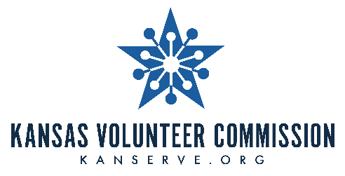

**For Immediate Release                                   Contact:**

June 23, 2025 Jessica Dorsey, (785) 296-3163

[jessica.dorsey@ksde.gov](mailto:jessica.dorsey@ksde.gov)

***EDITOR’S NOTE:*** *The Kansas Volunteer Commission shouldn’t be shortened to KVC. It should be written out as Kansas Volunteer Commission.*

**Kansas Volunteer Commission Seeking**

**New Board Members**

TOPEKA – The Kansas Volunteer Commission is looking for individuals who want to make a positive difference in Kansas communities.

The Kansas Volunteer Commission is a 22-member body that supports and promotes volunteer service to all Kansas citizens as an effective means to address community needs and foster a collective commitment to lifelong community service. The Kansas Volunteer Commission grants funds to AmeriCorps*Kansas and Learn and Serve America programs; encourages volunteerism for everyone from youth to seniors to people with disabilities; promotes volunteerism for disaster preparedness and response; and helps to strengthen and expand Volunteer Centers in Kansas. At present, the Commission administers more than $2.0 million in federal funding for AmeriCorps and Learn and Serve America programs statewide.

**TIME COMMITMENT**

* Bi-monthly meetings--approximately 4 hours at locations throughout the state
* Committee work and individual responsibilities--time commitment varies

**TERM**

* Board Members serve by appointment from the Governor for a term of three years

**BOARD MEMBER (COMMISSIONER) RESPONSIBILITIES**

* Establish and develop policy to be communicated through the Kansas State Service Plan
* Attend and participate in Kansas Volunteer Commission meetings – bi-monthly meetings (mileage reimbursement is available)
* Serve on committees and/or subcommittees to meet the purpose and goals of the Kansas Volunteer Commission
* Attend orientation and training events sponsored/supported by the Kansas Volunteer Commission
* Attend state events sponsored/supported by the Kansas Volunteer Commission
* Represent the Kansas Volunteer Commission at events located in your area of the state supporting volunteerism
* Assist in the development and review of grant applications submitted to the Kansas Volunteer Commission
* Aid in the evaluation of grant programs awarded by the Kansas Volunteer Commission
* Opportunity to attend national conferences/events (all travel expenses provided by the Kansas Volunteer Commission)

**NEEDED SKILLS AND ASSETS**

Our current board members have made significant and valuable contributions, but we have identified some skills and assets that need to be filled:

* Previous experience working with well-established volunteer organizations and nonprofit agencies
* Ability to network with leaders of local, regional and state agencies, corporations and community-based organizations
* Demonstrated skills in strategic planning, marketing and business management.
* A representative of local labor organizations in the state.
* An individual with experience in promoting the involvement of older adults in service and volunteering
* Individuals that represent the demographics of Kansas, including rural and indigenous representatives.

**APPLICATION**

* To learn more please visit the Commission Ambassador webpage [**here**](https://kanserve.ksde.gov/take-action/partner-with-us/become-a-commission-ambassador)**.**
* To apply click [**here**](https://www.governor.ks.gov/serving-kansans/office-of-appointments/apply-to-serve)**.**

*###*

*The Kansas Volunteer Commission is a program of the Kansas State Department of Education (KSDE). The vision of the Kansas Volunteer Commission is to empower all Kansans to meet community needs through service. The Commission's primary role is to provide resources and leadership to support local initiatives that tackle community needs. As the state service commission, the Kansas Volunteer Commission promotes AmeriCorps national service, volunteer engagement, youth mentoring and civic engagement. For more information, visit* [*www.kanserve.org*](http://www.kanserve.org)*.*