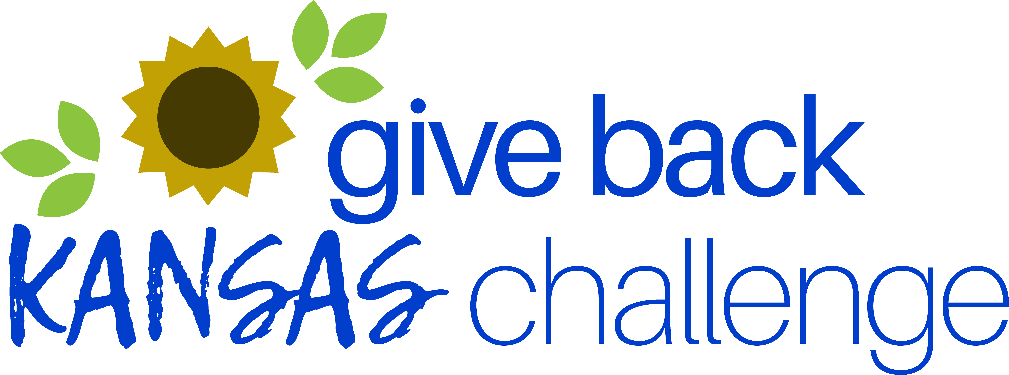

Join us for the Give Back Kansas Challenge!
March 31-May 23, 2025

Kansas has appeared on many best-of lists over the last few years, and we think it’s time to raise our efforts in volunteering and giving back to showcase how great our state truly is.

It’s a simple, fun way to get out in your community!

Volunteer and track your hours with your employer! Employers with the highest average number of volunteer hours per employee during the Challenge will be recognized and a $1,000 grant from Volunteer Kansas will be given to the nonprofit of their choice.
Get your competitive spirit on and get volunteering!

Research shows that employees who volunteer, experience:
Improved employee engagement
Increased organizational commitment
Greater job satisfaction

ARE YOU IN?

Please contact <COMPANY CONTACT NAME> at <EMAIL> to learn more and participate.
