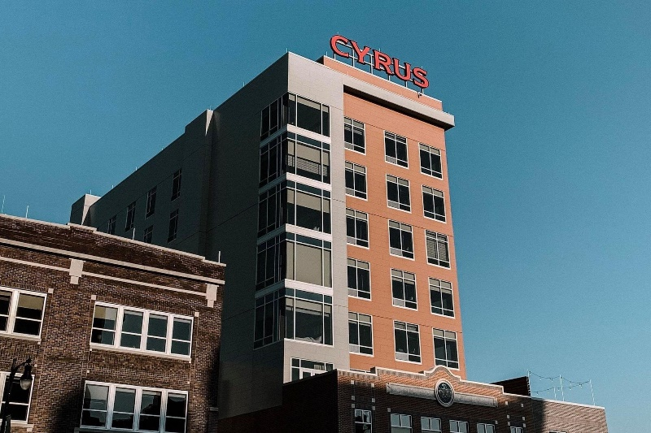

**Cyrus Hotel, Topeka, a Tribute Portfolio Hotel**

**920 S Kansas Ave, Topeka, KS 66612, US**

**(833)-372-7300**

[**Cyrus Hotel Reservation**](https://www2.reservationcounter.com/hotels/show/62570d7/cyrus-hotel-topeka-a-tribute-portfolio-hotel-topeka-kansas/?cid=sem::TPRC::AW::New_Structure_Reservation_Counter_US_Marriott_Other_Brands::US_Kansas_Topeka_Cyrus_Hotel_Topeka_a_Tribute_Portfolio_Hotel_did-62570d7_103117015::cyrus%20hotel%20topeka::p&creative=725879133087&device=c&AdPos=&utm_source=google&utm_medium=cpc&utm_term=cyrus%20hotel%20topeka&utm_campaign=New_Structure_Reservation_Counter_US_Marriott_Other_Brands&iv_=__iv_p_1_a_22042157266_g_175921339841_w_kwd-627687320395_h_1017653_ii__d_c_v__n_g_c_725879133087_k_cyrus%20hotel%20topeka_m_p_l__t__e__r__vi__&gad_source=1&gad_campaignid=22042157266&gbraid=0AAAAAD1Ss5xsSnQFvsbXPzgK3HlAMiuDg&gclid=CjwKCAjw2brFBhBOEiwAVJX5GGsodp1NqOzgrenfRPKi184oxJgtOiU962ABEeMLgqCKgdPTGSB_qRoCKdoQAvD_BwE)

[**See Map**](https://www.google.com/maps/place/Cyrus+Hotel,+Topeka,+a+Tribute+Portfolio+Hotel/@39.0464576,-95.675022,17z/data=!3m1!4b1!4m9!3m8!1s0x87bf031049fb0269:0x7c4fb9d38b377efb!5m2!4m1!1i2!8m2!3d39.0464576!4d-95.675022!16s%2Fg%2F11g4dj7_tp?entry=ttu&g_ep=EgoyMDI1MDgyNC4wIKXMDSoASAFQAw%3D%3D)

**Amenities:**

Internet Access

Fitness Center

Restaurant

Pets Allowed (conditions apply)

Room Service

Accessible

Meeting Facilities

Bar

Smoke free

Smoking Areas

24 hour

Concierge

Conference Center

Dry Cleaning

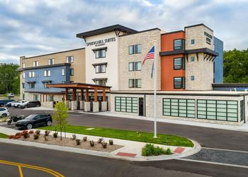

**SpringHill Suites by Marriott Topeka Southwest**

**2745 SW Fairlawn Rd, Topeka, KS 66614, US**

**(866)-381-0652**

[**Spring Hill Suits By Marriott Reservation**](https://www2.reservationcounter.com/hotels/show/6910ea3/springhill-suites-by-marriott-topeka-southwest-topeka-kansas/?cid=sem::TPRC::AW::New_Structure_Reservation_Counter_US_Marriott_SpringHill_Suites::US_Kansas_Topeka_SpringHill_Suites_by_Marriott_Topeka_Southwest_did-6910ea3_110169763::springhill%20suites%20topeka%20southwest::e&creative=725915764924&device=c&AdPos=&utm_source=google&utm_medium=cpc&utm_term=springhill%20suites%20topeka%20southwest&utm_campaign=New_Structure_Reservation_Counter_US_Marriott_SpringHill_Suites&iv_=__iv_p_1_a_22032073176_g_172285969637_w_kwd-948137506458_h_1017653_ii__d_c_v__n_g_c_725915764924_k_springhill%20suites%20topeka%20southwest_m_e_l__t__e__r__vi__&gad_source=1&gad_campaignid=22032073176&gbraid=0AAAAAD1Ss5ydl3NH3gc2bBC58G-yOz38S&gclid=CjwKCAjw2brFBhBOEiwAVJX5GLakCqekzkfr65tem4JkVShM-K91eum3LhOMV7Mb066iVD2sqY4rdRoCuD4QAvD_BwE)

[**See Map**](https://www.google.com/maps/place/SpringHill+Suites+Topeka+Southwest/@39.0162275,-95.7477514,16z/data=!3m1!4b1!4m9!3m8!1s0x87befd4c28ed60a7:0xfb0ce5f098c04438!5m2!4m1!1i2!8m2!3d39.0162275!4d-95.7451765!16s%2Fg%2F11mp2prdpj?entry=ttu&g_ep=EgoyMDI1MDgyNC4wIKXMDSoASAFQAw%3D%3D)

**Amenities:**

Internet Access

Swimming Pool

Fitness Center

Pets Allowed (conditions apply)

Room Service

Accessible

Meeting Facilities

Bar

Smoke free

Smoking Areas

24 hour

Concierge

Conference Center

Dry Cleaning

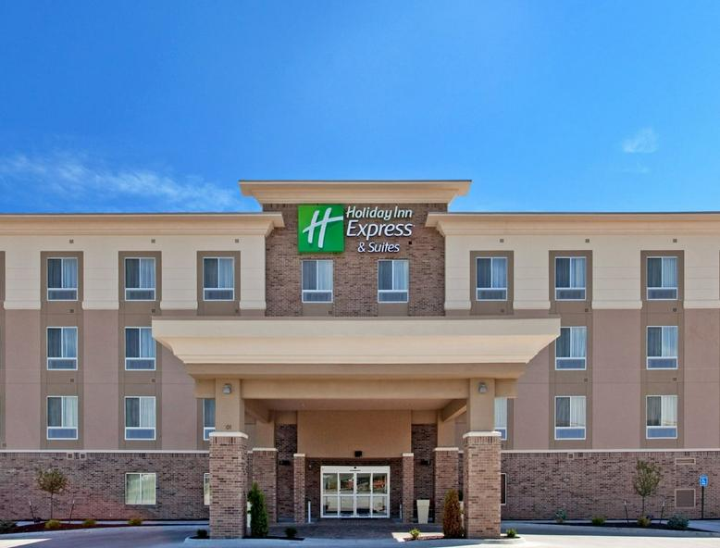

**Holiday Inn Express & Suites Topeka North by IHG**

**601 NW Highway 24, Topeka, KS 66608, US**

**(866) 381-0652**

[**Holiday Inn Express & Suites Topeka North by IHG Reservation**](https://www2.reservationcounter.com/hotels/show/61254a7/holiday-inn-express--suites-topeka-north-by-ihg-topeka-kansas/?cid=sem::TPRC::AW::::::::&creative=&device=c&AdPos=&utm_source=google&utm_medium=cpc&utm_term=&utm_campaign=&iv_=__iv_p_1_a_22393907259_g__w__h_1017653_ii__d_c_v__n_x_c__k__m__l__t__e__r__vi__&gad_source=1&gad_campaignid=22393910628&gbraid=0AAAAAD1Ss5wwD_V-V1-hxiTbPwyTe4Ow9&gclid=CjwKCAjw2brFBhBOEiwAVJX5GEY-CbAtAwVjEQkWW2z2XS74Kjn3v-vBSuI0D3hfAZJhOL29AvVzBRoCPJgQAvD_BwE)

[**See Map**](https://www.google.com/maps/place/Holiday+Inn+Express+%26+Suites+Topeka+North+by+IHG/@39.089741,-95.6726799,17z/data=!4m10!3m9!1s0x87bf03dce041f1fb:0x1a412e2bdb22aeb4!5m3!1s2025-09-17!4m1!1i2!8m2!3d39.089741!4d-95.670105!16s%2Fg%2F1vfn752h?entry=ttu&g_ep=EgoyMDI1MDgyNC4wIKXMDSoASAFQAw%3D%3D)

**Amenities:**

Internet Access

Swimming Pool

Fitness Center

Restaurant

Room Service

Accessible

Meeting Facilities

Smoke free

Smoking Areas

24 hour

Concierge

Conference Center

Dry Cleaning